Problem Statement XLR8 2014

**Robotics Club** presents **XLR8,** the opening event of the club, for freshmen. The event will be held on 23rd and 24th August 2014 i.e. Saturday and Sunday

***Task:***

To build a manually controlled bot capable of negotiating different kinds of obstacles and completing the designated track.

***Teams:***

* Maximum number of members in a team is 4.
* Only freshmen entries will be considered for prizes.
* The teams must register online through the link: http://stab-iitb.org/robotics-club/event till 11.59 pm of 15th August’14.

Registrations starts Tuesday i.e. 12th Aug’14

We hold no responsibility to allot any time slot or provide mentorship facility to un-registered teams.

***Venue:***

The competition will be held in Shailesh J. Mehta School of Management (SOM) Well. Please note that that the arena may possibly be wet.

***Machine Specifications:***

1. The entire bot must fit within a box of size 25cm x 25cm x 25cm at all points of time during the run. This does not include the remote control and external power supply (if any).
2. If the power supply is onboard, then it must fit into the above mentioned box along with the machine at all points of time during the run.
3. There are no weight-restrictions on the machine.
4. The machine can be wired or wireless. Power supply can be external or on-board. No points would be deducted for off board battery.
5. Voltage between any two points on the machine should not exceed 12 V at any point of time during the race.
6. No readymade steering mechanisms are allowed. Readymade gears, shafts however may be used.
7. Lego kits are **not** allowed.

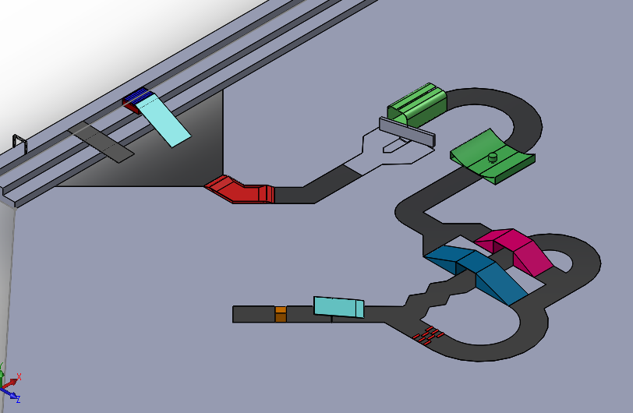

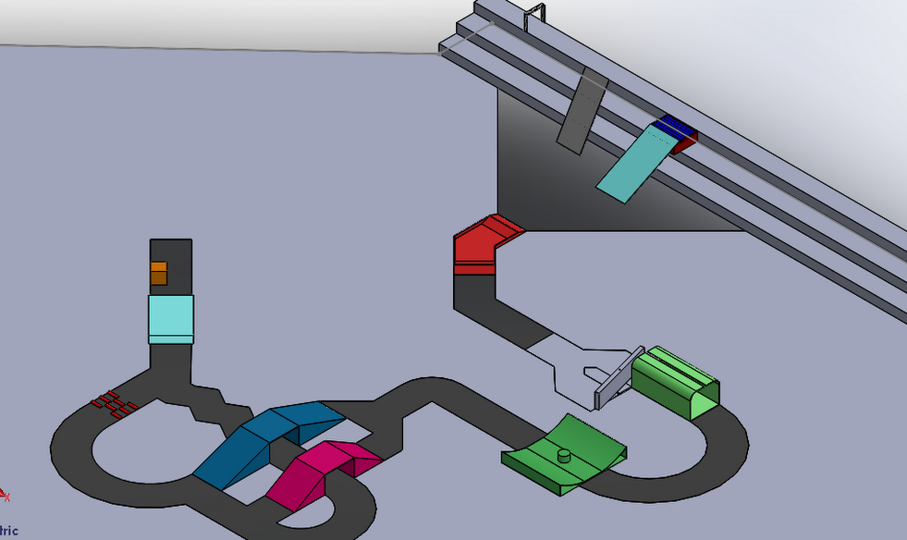

***Arena Specifications:***

1. The teams will have to compete with their cars on a track designed for the competition. The track will either be bounded on both the sides by tires or will be clearly defined by some other means. The width of the track will be between 40cm and 50cm.
2. The track surface, on which the teams will have to race their cars, will be SOM well floor, except the inclined tracks which are made up of plywood and the marble-pit. There will be covering of sand paper on some parts of plywood.
3. **Obstacles:**

There will be obstacles placed on the track. These obstacles will be as follows:

1. **Rollers (60):**  A bunch of free-to-rotate rollers would be present in the track. The car has to go over these rollers.

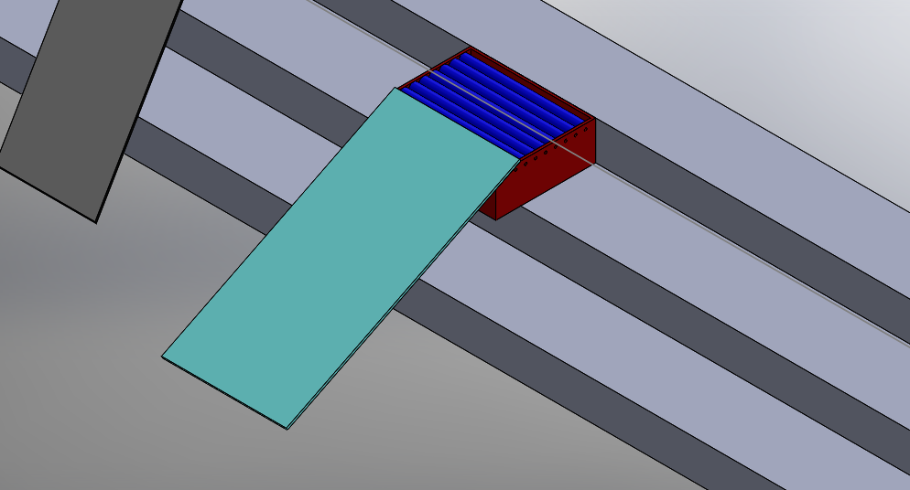

1. **Oblique incline (30):** The bot has to come down an obliquely-oriented slope.



1. **Pebble pit (30):** This will be an area where small and medium sized marbles and/or pebbles will be put. The bot must trudge its way out without getting stuck. The angle of turn is 45 degree

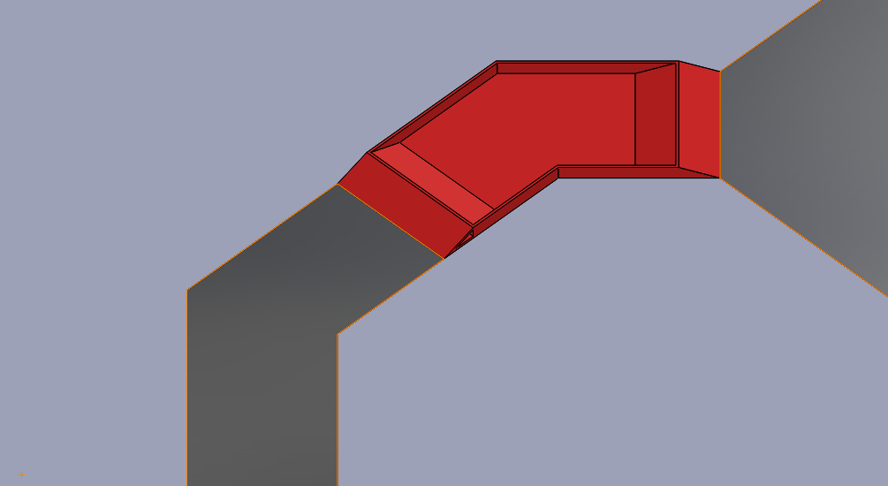

1. **Door mechanism (30):** The track will be blockedby a rotating ‘door’ which can be opened by pushing against a rod, connected to the door, but on the other side of the pivot as shown. Thus after ensuring the door is rotated via the rod, the bot needs to get back onto the main track to continue.

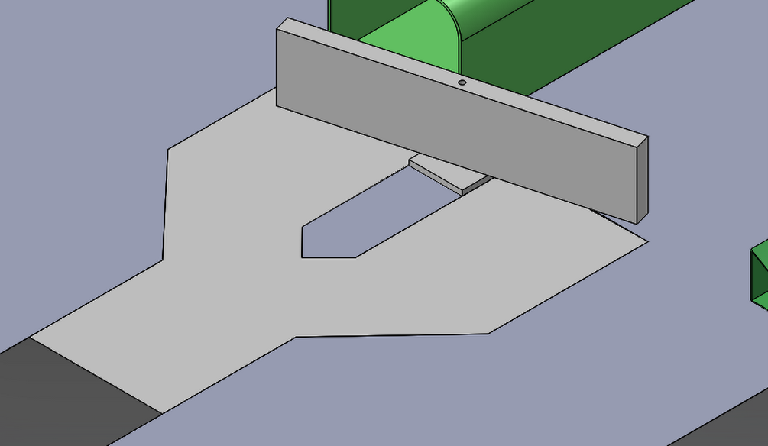

1. **Tunnel (60):** The tunnel will be of length 1 meter, and will have a narrow slit at the top just adequate for the wire of a wired bot to pass.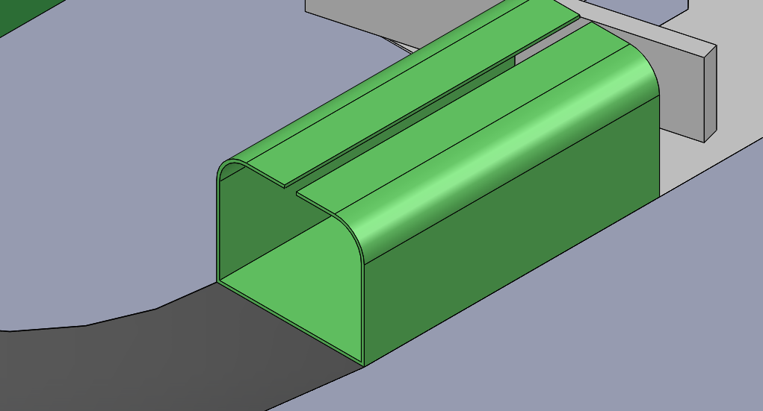
2. **Cylindrical Bowl (40):**  It essentially is a section of a cylindrical surface along which the car needs to move, negotiating the impeding pole in between as shown.

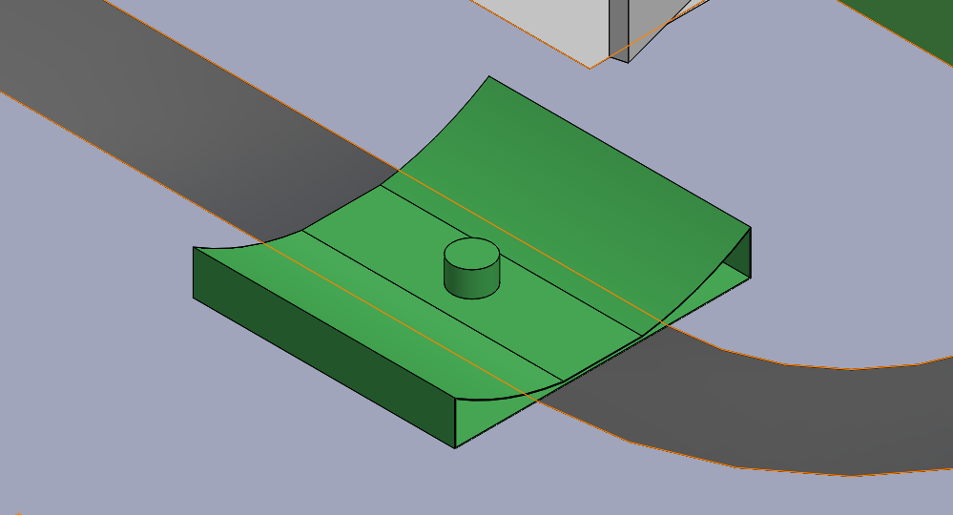

1. **Inclines (60/80):**  There will be two inclines (35°and 20°) which the bot needs to climb up and then climb down, without falling off.

**\*\* Wireless can take any of the path after the incline.**

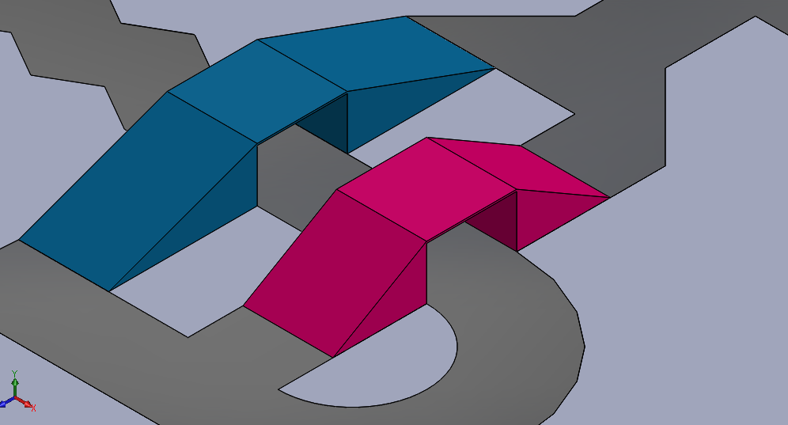

1. **Speed Breakers (50):** The car needs to sail through a patch of bumpy speed breakers of same dimensions, maintaining its orientation successfully. Size of base of ZIgZag is 170mmx50mm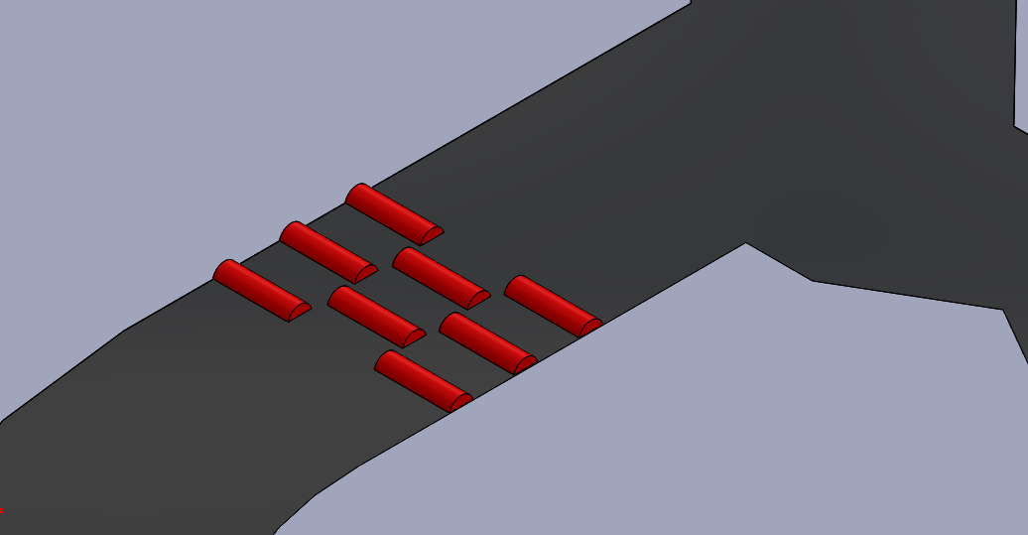
2. **Zigzag (30):** Maneuver your bot through the zigzag turns, without spending too much time. Angle of Zigzag is 120 degree



1. **Seesaw (70):** A plank kept at an angle of 19 degrees while moving up and lengths of both the halves are different, the upward incline being smaller in length. Thus the car has to move to the center to switch the direction of incline and then climb it down.

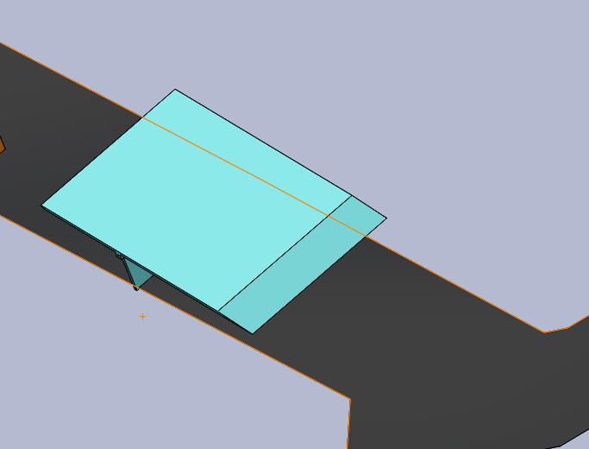

1. **Push block (30):** In this section, placed at the end of the track, the team **may** choose to drag along (by means of pushing), a block of weight xx kept in middle of the track, across the finish line. While this earns the team extra points, the team may also choose to complete the track without pushing the bock along, however at the cost of earning no points in this section.

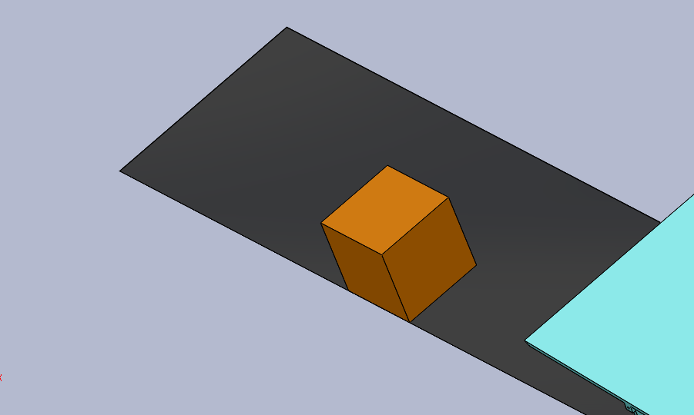

1. **Surprise element:** Be prepared to tackle an additional element which will serve as a surprise! Keep guessing!!

***Scoring*:**

For every obstacle there are certain number of points allocated, which will be awarded after its successful completion.

|  |  |
| --- | --- |
| **OBSTACLE** | **POINTS** |
| Rollers | **60** |
| Oblique descent | **30** |
| Pebble pit | **30** |
| Door | **30** |
| Tunnel | **60** |
| Cylindrical bowl | **40** |
| Incines | **60/80** |
| Speed breakers | **50** |
| Zig zag | **30** |
| See saw | **70** |
| Push block | **30** |

**Final score** = A+B*

A = total points scored (By clearing obstacles.) B = (180- time taken)*2

*points in (B) will be awarded only if all the mentioned hurdles in the track are successfully crossed, within 180 seconds

**Appreciation Score:** An additional 100 points would be awarded to the teams whose bot can complete the track without the usage of ‘time-out’.

*a ‘reset’ would be considered to be a deliberately done placing of the bot to the previously done checkpoint and a ‘time-out’ would be considered to be a break taken for repairing technical damages or similar issues.

***Rules:***

1. Maximum of 2 team-members will be allowed to control the car at a time.
2. Teams will not get any extra time for practice, testing or calibrations on the arena before the final run.
3. There will be certain number of check points on the track, which will be informed to the participants before the start of the run. If a machine falls from a height off the track or gets stuck, then it will be placed back on the last check point the machine has passed. This will be done by the organizers. Teams are not allowed to touch the machines during the run (except if the team announces time-out as per rule 4). The timer will keep running during this process. No Strategic timeout advantages will be permitted, any team attempting to do so will be disqualified.
4. There will be a time-out allowed per team exactly once during the round. If the team calls for a time-out, the timer for that round will be paused and the team will get a maximum of 2 minutes to place the car back at the last reset point it has crossed after which the timer will be un-paused and the car must complete the rest of the track from the previous checkpoint.
5. If a car is unable to move for more than 30s then it will be assumed that the car has failed and that round will be considered to have ended.(Time would pause and resume after application and removal of timeout respectively)
6. Wires (if any) must remain slack at all points of time during the competition. Severe time penalties will be imposed for the intentional/unintentional violation of this rule.
7. Other communication devices are not allowed (including other RC remotes) near the arena while the competition is on. This includes remote control of your car while some other team’s run is on. The organizers hold the right to check for these devices and their usage.
8. Machines found damaging the arena will be liable for disqualification.
9. On board batteries would be awarded an additional 50 points.
10. If after a checkpoint there exist 2 paths-one alternative for the other, the team can put the bot themselves to the checkpoint after completing one alternative to complete the other alternative. However, time would not stop during this process.
11. No extra points will be awarded for completing the same hurdle more than once.
12. Mobile controlled and Bluetooth controlled bots would be awarded an additional 100 points.(for PGs only)
13. Each team will get 2 laps, out of which best will be considered for final scoring.
14. All the teams are requested to be present for their runs during their respective time slots. The organizers do not hold the guarantee of reallocating a new time slot for latecomers.
15. The time measured by the organizers will be final and will be used for scoring the teams. Time measured by any contestant by any other means is not acceptable for scoring. In general, the decision of the organizers will be final and binding in all circumstances.

***Contact:***

*MANAGERS:*

* Chetan Agrawal: 09167469004
* Vineetha Reddy: 09819915441

*CONVENERS:*

* Aditya Mate: 09892430170
* Hardik Seth: 09987692500
* Madhur Maheshwari: 09967352622
* Rushil Modi: 09167229212
* Rishabh Choudhary: 08454041915
* Aishwary Joshi: 07506122580
* Maithili Patel: 09172413114
* Kedar Joshi:-09819097671